**Experiment – Privacy Technology company offering pretrained model to financial institutions.**

PTFI provides state of the art AI solutions to combat financial crime. It offers pretrained model as a service. On top that it is using privacy enhancing technologies to keep sensitive data private for all parties involved.

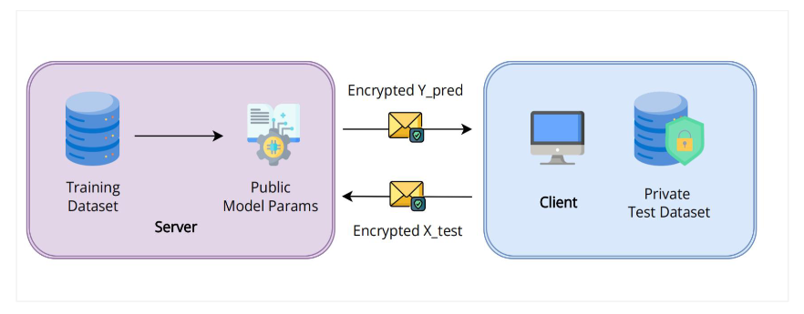

**Scenario (Use Case)**

We have a pretrained classifier model that predicts credit fraud. We specialise in building state of the art models to combat financial crime.

A bank wants to use our model to predict credit fraud on using their own data.

**How do we do this?**

1. Train credit fraud classifier model on server (our) using the synthetic data (***That is why we need a synthetic data related to credit transactions with a target variable fraudulent credit transaction***)
2. Encrypt the data of the bank.
3. Send the encrypted test data (bank data) to the server (ours)
4. Use unencrypted model parameters for inference.
5. Send model predictions back to the bank.
6. The bank will decrypt output predictions and calculate accuracy.

This is experiment can be done using python. This is a simple example showing how privacy preserving technology like HE or federated learning can be utilised to combat financial crime.